Bismillaahir Rahmaanir Raheem
69th Indian Independence Day Celebrations
at Madrasa e Zehra, Perambur
15th August 2015 (Saturday)
As Salaamu Alaikum,
India got independence from the British Empire on 15 August 1947. On 15 August 1947, Jawaharlal Nehru became the first Prime Minister of India.
The holiday is observed throughout India with flag-hoisting ceremonies, parades and cultural events. Independence Day is one of the three national holidays in India, the other two being the Republic Day on 26 January and Mahatma Gandhi's birthday on 2 October.
The National Flag of India is a horizontal rectangular tricolour of deep saffron, white and India green; with the Ashoka Chakra, a 24-spoke wheel, in navy blue at its centre.
Program
Title: India’s 69th Independence Day Celebrations Program
Date: 15th August 2015 (Saturday)
Time: After Namaaz e Maghribain
Venue: Madarasa e Zehra (sa), Thillai Nayagam Street, Perambur, Chennai – 600011.

Workshop: 1 COLOUR OUR NATIONAL FLAG
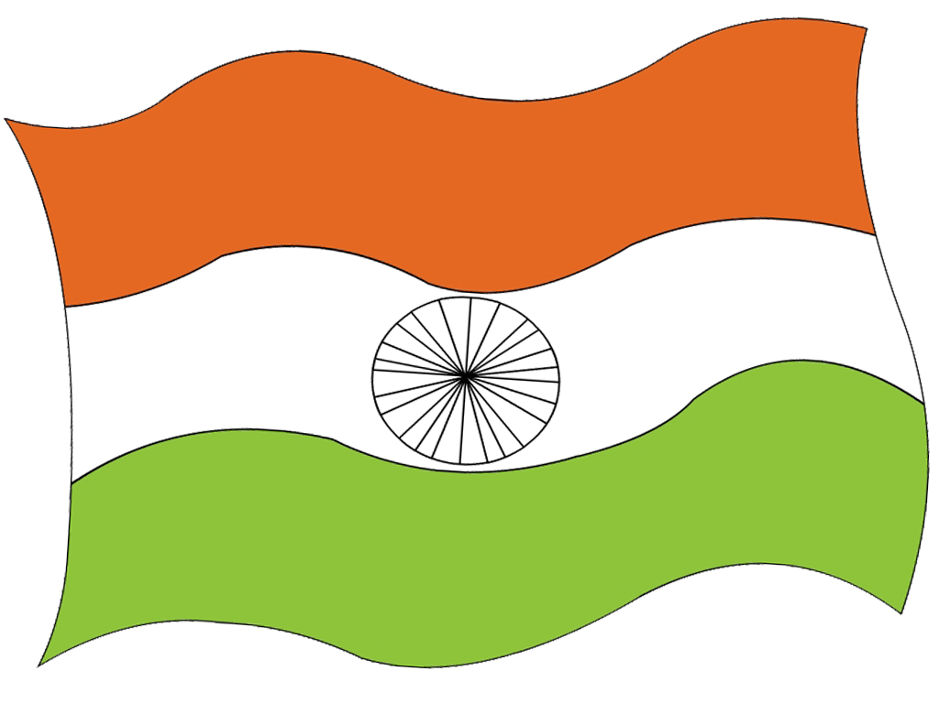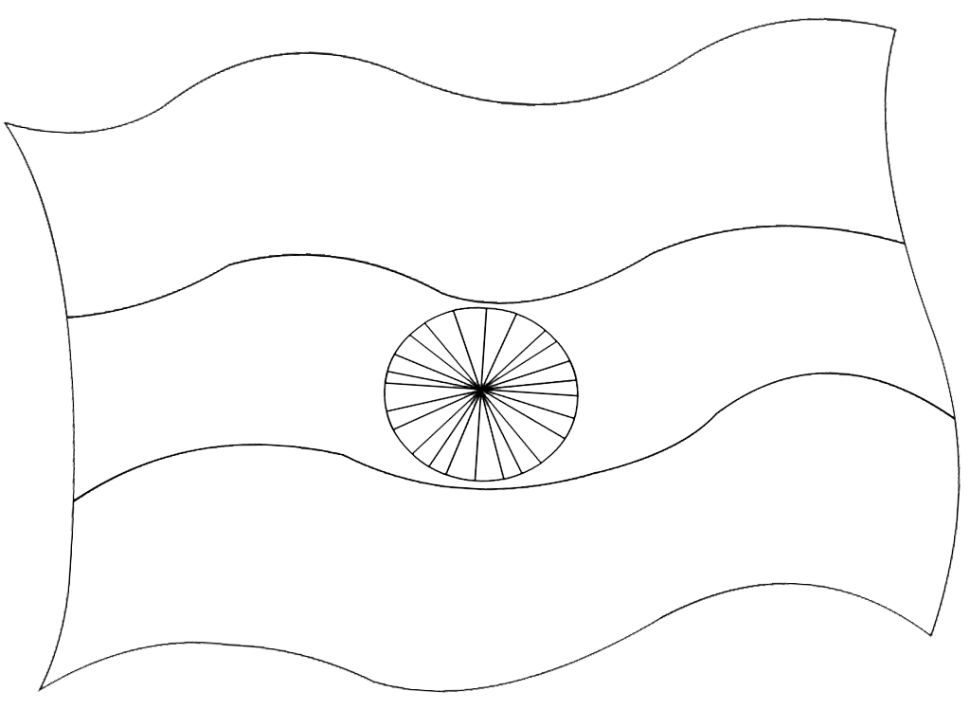

What does Patriotism means:
Patriotism means loyalty of person to his/her own nation or the leaders of nation. A patriot is a person who is on the side of his/her own nation or its leaders.
Workshop 2: Draw ‘I Love My India’
Example:
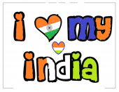
National symbols of India:
Nattional Emblem of India is Ashoka Chakra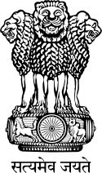
National Flower is Lotus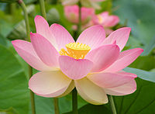
National Animal is Tiger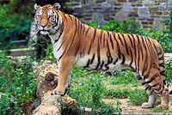
National Bird is Peacock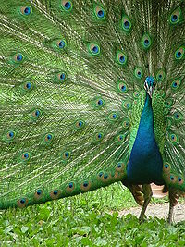
National Currency of India is Rupee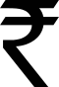
National Tree is Banyan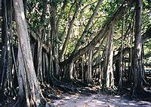
National River is Ganga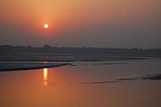
National Fruit is Mango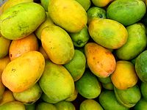

Islamic Workshop and Activities:
Paint/Colour the Masjid
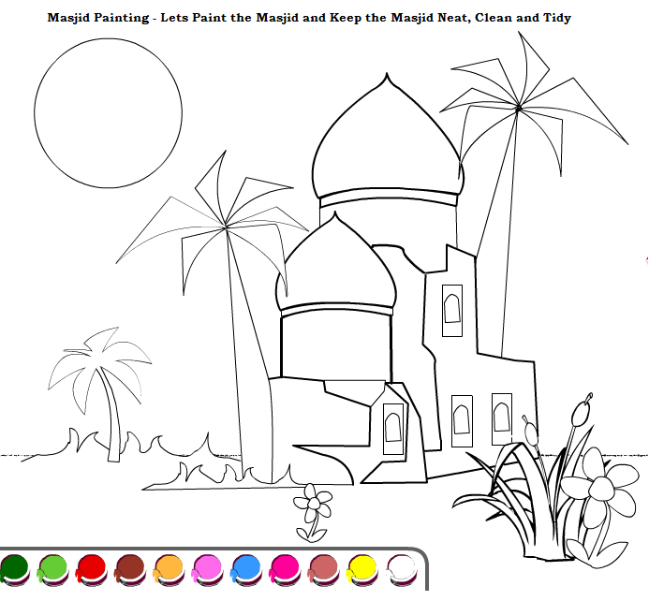

Fill the Missing Word
Fill in the missing word to find the name of the perfect person, place or a Thing
I S L _ M . ALL_H
Q_RAN . MU_AMMAD
AL_ . ME_DI
_ADEES . KA_ATULLAH
KA_BALA . MUSALL_
Islamic Crossword Workshop:
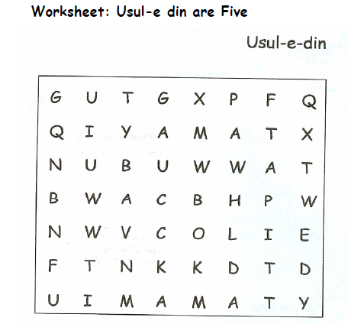
Mark the Uslooe e Deen (Roots of Islam)
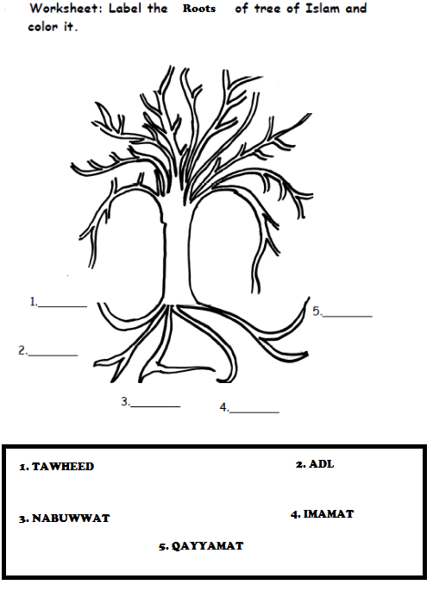

Mark the Furoo e Deen (Branches of Islam)
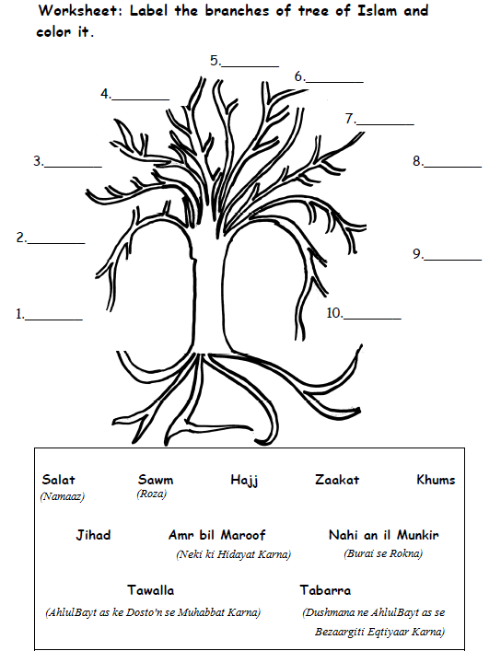
Allaahumma Solle ala Muhammad wa Aale Muhammad wa Ajjil Farajahum

